Rapport :SpreadSheet

In the our last iteration of the SpreadSheet we did obtain an application with:
- Menu Bar
- Two tools bars
- Status bar to print the informations

- At result we have an application that looks like that :
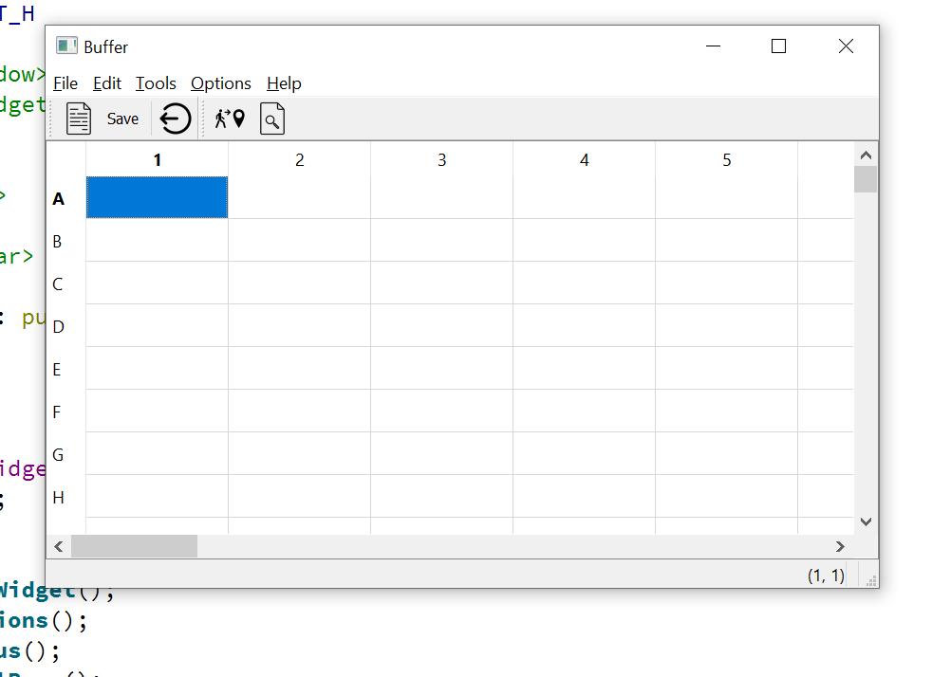

Go Cell :
Now we will add the function for the goCell action. For that, we need to create a Dialog for the user to select a cell:
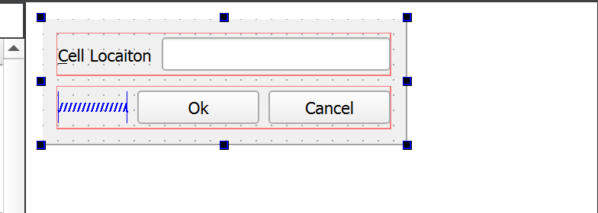
- here an example that shows the functionality of GoCell:
- Its condition is to start with a character
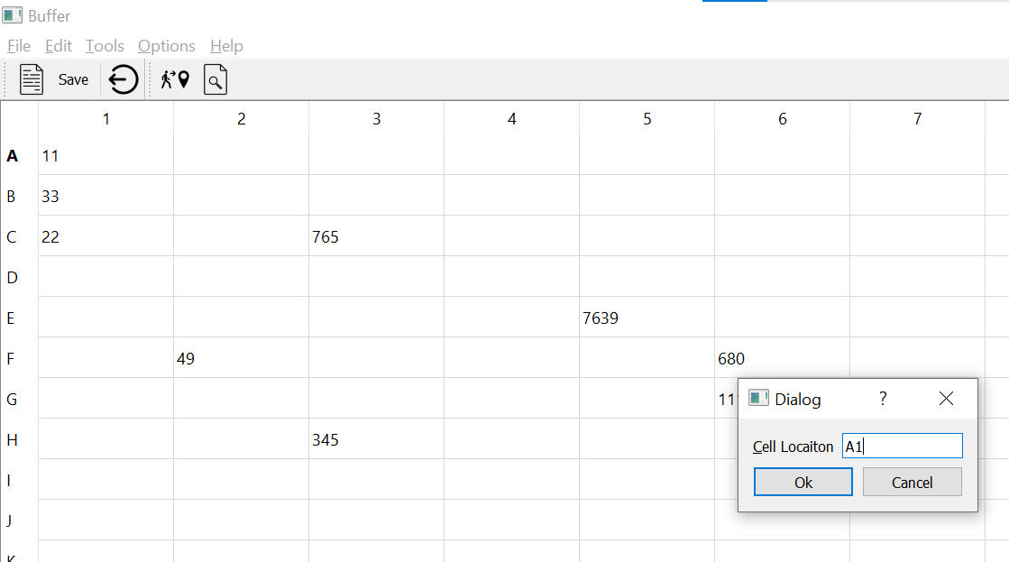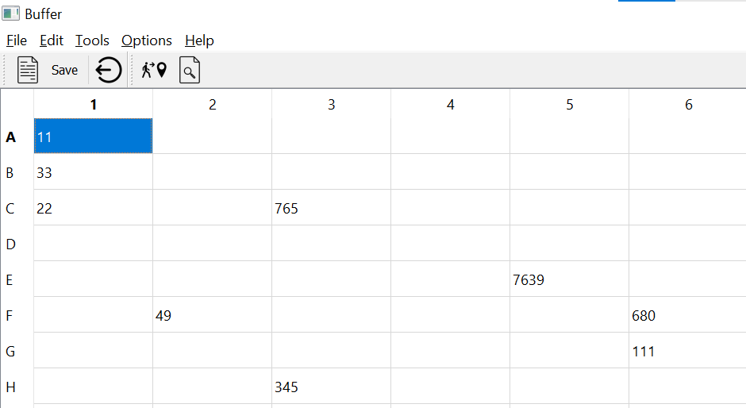

Find Dialog :

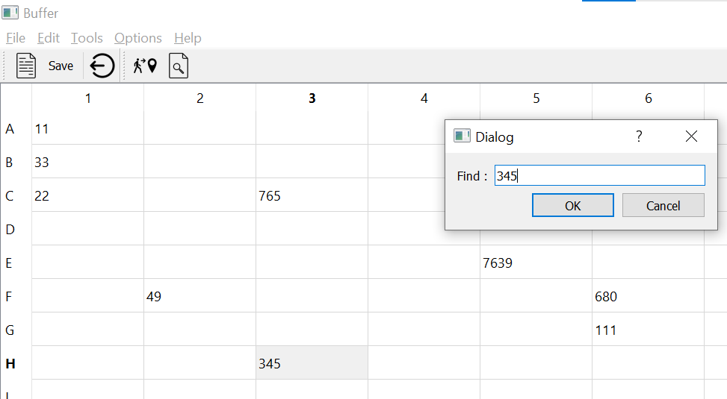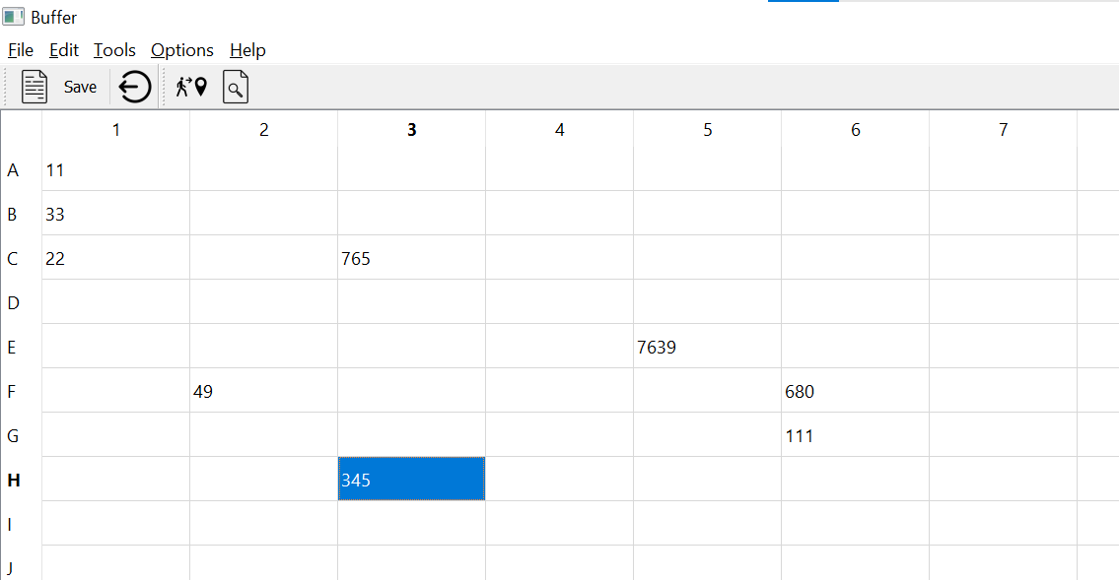

Saving and loading files :

